WEEK 12 REPORT
Electronics Retail
Sales Performance Analysis

1. Dashboard Overview
The dashboard presents the sales performance of an electronics retail business through online and physical stores. It brings together revenue, profit, order volume, product categories, city-wise performance and monthly revenue in one report. The visuals help identify the strongest sales channel and the areas that may need further attention.
Dashboard Snapshot
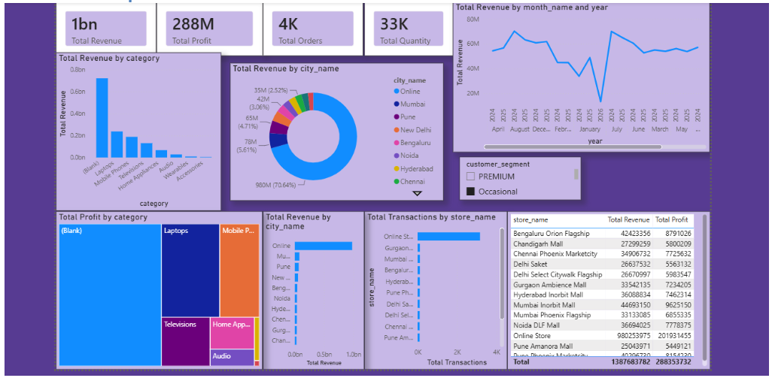

2. Key Performance Indicators
The four cards at the top provide a quick summary. The revenue card is displayed as approximately 1bn, while the detailed total row in the store table shows ₹1,387,687,382. The difference is due to the compact rounded display on the card.
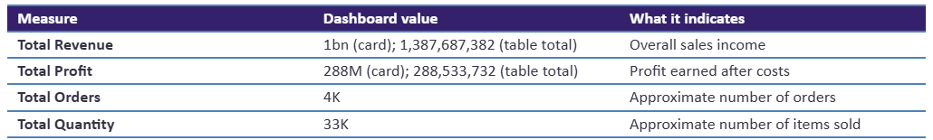
Using the detailed totals, profit is about 20.8% of revenue. This gives a useful overall view of profitability, although the dashboard should be checked to ensure that all cards and totals use the same filters and formatting.

3. Revenue by Product Category
The category column chart shows a large amount of revenue assigned to the “(Blank)” category. Among the named categories, Laptops have the highest revenue, followed by Mobile Phones and Televisions. Home Appliances contribute a smaller amount, while Audio, Wearables and Accessories appear at the lower end.
- Laptops and Mobile Phones are important named product groups for sales.
- The large “(Blank)” category makes it difficult to judge the true contribution of every product group.
- Product category details should be completed before making major category-level decisions.
4. City and Sales Channel Performance
The donut chart indicates that the Online channel contributes ₹980M, equal to 70.64% of the revenue shown in that visual. The remaining revenue is shared by physical locations such as Mumbai, Pune, New Delhi, Bengaluru, Noida, Hyderabad and Chennai. Each physical location contributes a much smaller share than Online.
The store revenue chart supports the same pattern. The Online Store is the leading source of revenue, while the individual mall and flagship outlets contribute smaller amounts. This suggests that the business currently depends strongly on its online channel.
5. Transactions by Store
The horizontal bar chart compares the number of transactions across store names. The Online Store has the longest bar and is clearly ahead of the physical outlets. The other stores have shorter bars, showing a lower transaction count in comparison. This pattern is consistent with the city-wise revenue chart, where Online is also the largest contributor.
6. Monthly Revenue Pattern
The line chart displays revenue across month and year labels. Revenue changes from month to month, with one noticeable fall followed by a sharp rise. However, the month labels appear in a non-chronological order and the year labels repeat. Therefore, the line should not be treated as a reliable time trend until the date field is sorted correctly.
- Sort the visual using a proper date column or a Year-Month key.
- Check the month with the unusually low revenue to confirm whether its data is complete.
- After correcting the order, compare monthly revenue to identify genuine growth or decline.
7. Customer Segment Filter
A customer segment slicer is provided with options such as PREMIUM and Occasional. This filter can be used to view the dashboard for a selected customer group. Comparing segments may help the business understand whether high-value customers and occasional buyers contribute differently to revenue and profit.
8. Main Observations
- The detailed store table reports total revenue of ₹1,387,687,382 and total profit of ₹288,533,732.
- Online is the dominant sales channel, contributing 70.64% of revenue in the city revenue visual.
- Laptops, Mobile Phones and Televisions are the strongest named product categories by revenue.
- The “(Blank)” category is unusually large and affects the reliability of category comparisons.
- The Online Store leads the transaction chart by a wide margin.
- The monthly revenue chart needs chronological sorting before it can be used to explain a sales trend.
9. Recommendations
- Correct missing category values: Review the product and sales tables and check the relationship between them. Assign valid categories to products that currently appear as “(Blank)”.
- Improve the time-based visual: Create or use a proper date field and sort the month-year labels chronologically. This will make monthly comparisons easier to understand.
- Review the low-revenue month: Verify whether the sharp dip is caused by incomplete records, a genuine fall in sales or a reporting issue.
- Strengthen physical-store performance: Compare each outlet's revenue and transactions to identify stores that may benefit from local promotions or operational improvements.
- Use customer segments for analysis: Apply the PREMIUM and Occasional filters to compare customer behaviour and plan suitable marketing activities.

10. Conclusion
The Power BI report gives a clear snapshot of an electronics retailer's performance. Its most important finding is the strong contribution from the Online Store, while Laptops, Mobile Phones and Televisions lead among the named product categories. The dashboard also highlights two areas for improvement: the large amount of revenue recorded under “(Blank)” and the non-chronological month display. Correcting these issues will make the report more accurate and help the business make better decisions about products, stores and customers.

